Chapter 10, Solution 21.

- 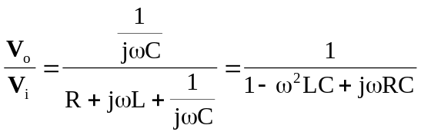
At 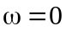, 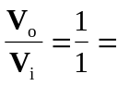 1
As , 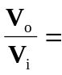 0
At 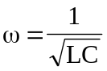, 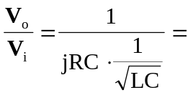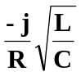

- 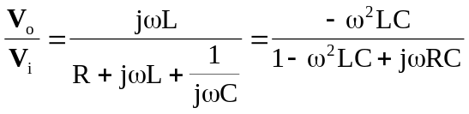
At , 0
As , 1
At , 